Vocabulary Quiz #2 Name _________________________________ Class _________

Fill in the blanks using the word bank below.
- Angles that share a common vertex and a common ray are ______________________ angles.
- Angles whose measures sum to 180⁰ are called _____________________ angles.
  - Each angle is the __________________________ of the other.
- When 2 lines intersect they form 4 angles. Angles across from each other are __________________ angles, and they are congruent.
- Angles whose measures sum to 90⁰ are called _______________________ angles.
  - Each angle is the __________________________ of the other.
- Angles are __________________ when they have the same measure.
- 2 angles that are adjacent and supplementary, and form a line are called a ______________________________.
Supplementary
Adjacent
Complementary
Linear Pair
Supplement
Complement
Vertical
Congruent

Match the term to its definition.
- Right Angle ______ Angle whose measure is less than 90⁰
- Straight Angle ______ Angle whose measure is 90⁰
- Acute Angle ______ Angle whose measure is 180⁰
- Obtuse Angle ______ Addition
- Sum ______ Angle whose measure is greater than 90⁰
Name the following angles:
3
A
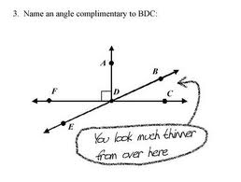
C
B

Name an angle that is complimentary to angle BDC

