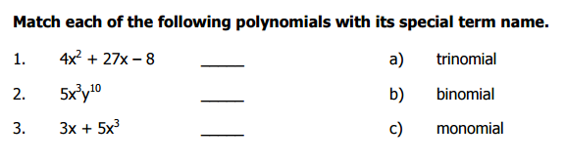
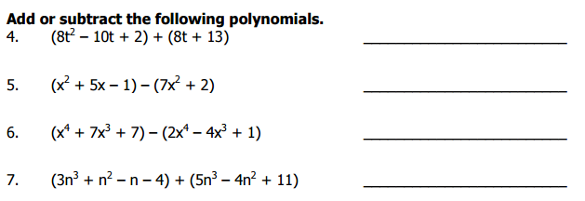
WORK SPACE:

Simplify the following
8.
9.

10. Multiply
11.
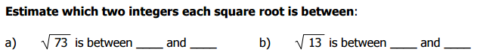
12. Simplify

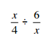
13. Solve for y
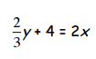

14. Explain the difference between the simplified version of
${-6}^{2} and {(-6)}^{2}$

15. Explain how you find the different answer to the following:
$$\sqrt[2]{64x^{12}} and \sqrt[3]{64x^{12}}$$

