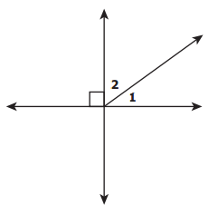 | What is the value of x?  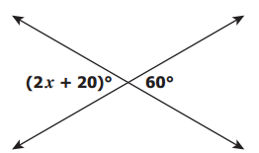
In which figure are angles 1 and 2 corresponding angles? | Which two segments are most likely parallel?  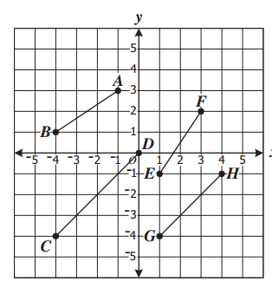
Which of the following statements would determine that the lines are parallel?  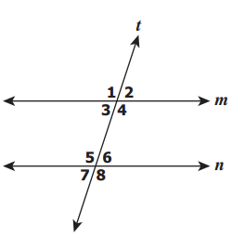  Answers choices to the right  Give the inverse to the following statement:  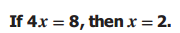 | 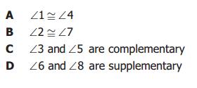
Find the logical conclusion to the following statements and name the law:
If you read books, then you will have a better world view.
If you have a better world view, then you will be more tolerant.

Find the logical conclusion and name the law:
lf I miss my bus, then l'll be late for school. I miss my bus.

lf p=11 is raining, and q=penguins are awesome

Write "lf it is raining, then penguins are awesome." in symbolic format.
Angles whose measures sum to 180⁰ are called_______________________

