Simplify:
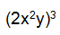
Simplify:
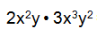
Simplify:
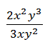
Simplify:
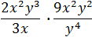

Evaluate the following expression for x = 2, y = 5 and z = 4
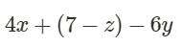
Evaluate when m=9 and p=3
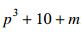

What is the best classification for $\sqrt{11}$
- Rational number, real
- Whole, integer, real
- Integer, rational, real
- Irrational, real
Evaluate for when y=10 and z=2
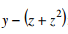
For a walk-a-thon a sponsor committed to give you a flat fee of $5 plus $2 for every mile m you walk.

Write an expression for the total amount you will collect from your sponsor at the end of the walk-athon.

Then evaluate your expression for 20 miles walked.

Solve for x.

3x+10=40

