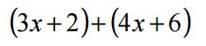 | 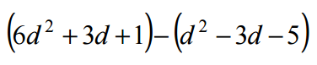
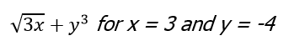 | 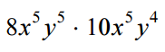
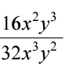 | 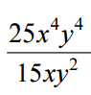
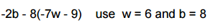 | 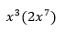
Evaluate for 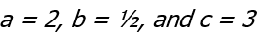  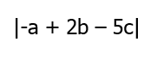 | Evaluate using the replacement set

