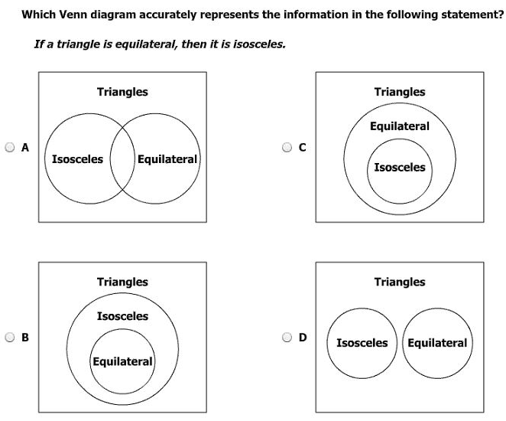
Which ratio represents the slope of a line parallel to j?  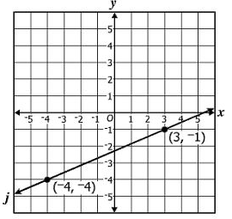 | 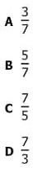
What is the converse of
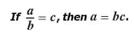
Line m has points A(3,-4) and B(7,0) write the equation of the line
Perpendicular to m through point P (8,12).

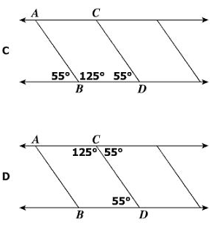

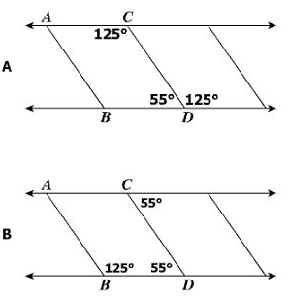
The two streets are parallel. What is the value of x?
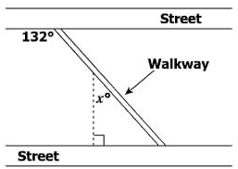

Construct the bisector of AB.
B

E
A
D
C

