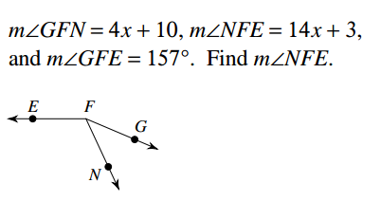
What is the midpoint of PQ?
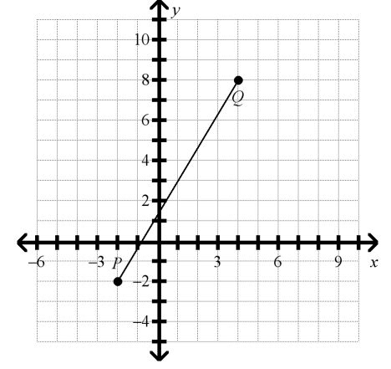
What is the converse of the statement below?
“If today is Friday, then tomorrow is Saturday.”

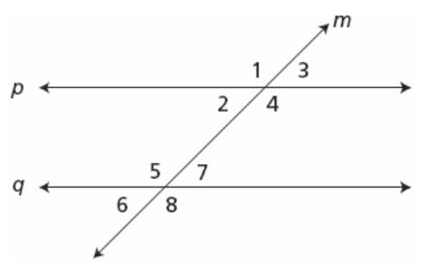
Which statement is not true?
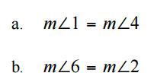
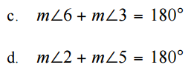

For what value of x are the lines parallel?
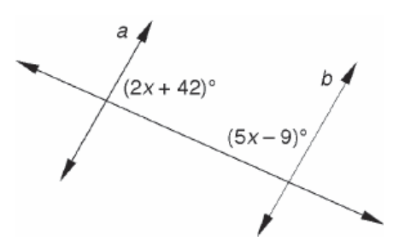
Order the sides from longest to shortest:
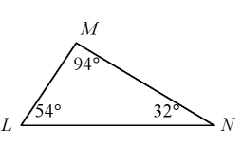
Can the following lengths make a triangle?

- 89,45,102

- 33,20.5,26
What possible values could make up the third side of a triangle with two sides of lengths 6 and 13?

What is the missing endpoint, when given the midpoint (4,5) and one endpoint (12,24)?

What is the inverse of the statement below:
“If you live in Tallahassee, then you live in Florida.”

